Ansible vault

1. Creating the vault file.



Write the play book here

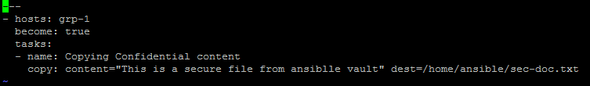

Now your file will be encrypted

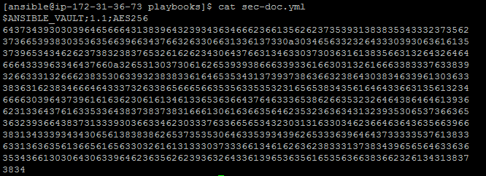

If you want to edit the file use below option



To view the encrypted files.

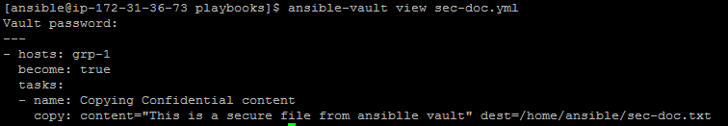

To encrypt the existing files.

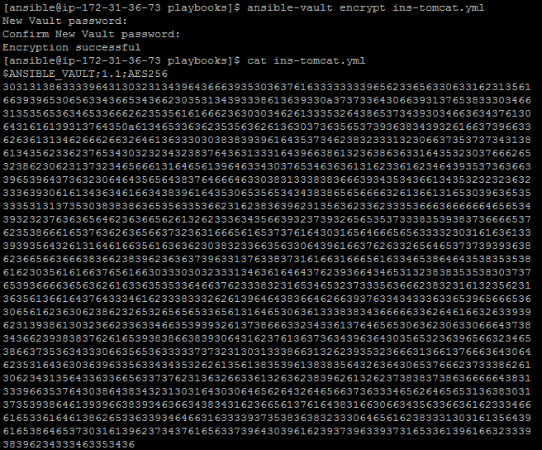

To change the encryption key

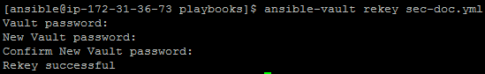

Run the encrypted ansible playbook

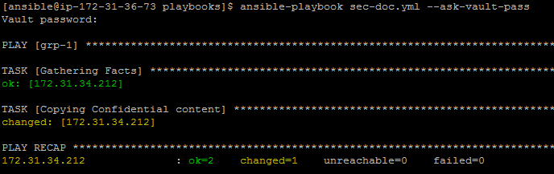

You will get below error without using encrypt option



Decrypt the file

